**Assignment-1**

**Draw your Home Network Topology and explain how you are accessing the RPS Lab environment.**

A **home network topology** describes the way various devices in your home network are connected to each other and to the internet. The general components to include in your topology are:

1. **Internet Source (ISP Modem/Router):**
   * This is where your internet connection originates, typically provided by your Internet Service Provider (ISP).
   * The modem or router connects to the outside world (ISP).
2. **Router:**
   * This device connects your home network to the internet. It often includes Wi-Fi functionality, which allows devices like laptops, phones, and tablets to access the internet wirelessly.
3. **Devices on the Network:**
   * **Wired Devices** (such as desktop computers, printers, or servers).
   * **Wireless Devices** (such as smartphones, laptops, smart TVs, etc.).
   * These devices connect to the router either via Wi-Fi or Ethernet cables.
4. **Network Switch (Optional):**
   * If you have more wired devices than your router’s Ethernet ports allow, you can include a switch to expand your network’s Ethernet capability.
5. **Access Point (Optional):**
   * If you have a large house or need additional Wi-Fi coverage, an access point may be used to extend your wireless network.

### Example of Home Network Topology:

1. **ISP** (Internet Connection)
   * **Modem/Router** → **Router** → (Wi-Fi or Ethernet)
     + **Devices**: Desktop, Laptop, Printer, Smart Devices (TV, Phone, etc.)
   * **Optional**: **Network Switch** to connect multiple devices (wired).
   * **Optional**: **Wi-Fi Access Point** to extend the Wi-Fi coverage.

### Part 2: Accessing the RPS Lab Environment

To access the **RPS Lab environment** (which could be a remote server or virtualized environment used for various tasks like networking labs or simulations), you likely use one of these methods:

1. **VPN (Virtual Private Network):**
   * If the RPS Lab environment is hosted on a remote server, the most common way to access it is by using a VPN.
   * This establishes a secure, encrypted connection between your home network and the lab network.
   * Once connected to the VPN, you can access the resources in the lab as if you're directly connected to that network.
2. **Remote Desktop Protocol (RDP) / SSH:**
   * If the RPS Lab provides access via Remote Desktop (for Windows systems) or SSH (for Linux systems), you can connect to a specific lab machine by using RDP for GUI-based access or SSH for command-line access.
   * You'll need the RDP or SSH client and login credentials (like username and password or keys) to access the server.
3. **Cloud Services / Virtualization:**
   * If the RPS Lab environment is based on cloud services (AWS, Google Cloud, etc.), you might use a browser-based interface or a cloud CLI tool to access and manage the lab systems.
   * Credentials and proper network configurations are needed to access virtual machines or environments in the cloud.

### Example Explanation for Accessing the RPS Lab:

1. **VPN Access:**
   * "To access the RPS Lab environment, I connect to a VPN provided by the institution. The VPN securely tunnels my home network traffic to the lab network, allowing me to access lab resources as if I were physically on campus."
2. **RDP/SSH Access:**
   * "After connecting to the VPN, I use **RDP (Remote Desktop Protocol)** to log into the Windows-based lab systems. Alternatively, for Linux-based systems, I use **SSH** to access 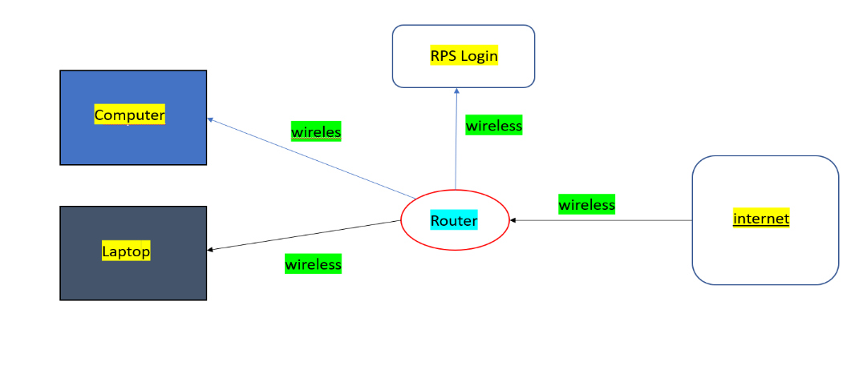

**Assignment 2: Real-world Applications of Parallel Computing and Networked Systems\**

Parallel Computing: Weather Forecasting

How it's used:

Weather forecasting involves complex mathematical models that simulate atmospheric conditions. Parallel computing allows these models to be broken down into smaller sub-problems, which can be processed simultaneously by multiple processors. This significantly speeds up the computation time, enabling more accurate and timely forecasts.

Why it's important:

Accurate Predictions: Parallel computing enables the processing of vast amounts of data from various sources, leading to more precise weather predictions.

Timely Forecasts: Faster processing speeds allow for real-time updates and warnings, which are crucial for public safety and decision-making.

Improved Climate Modeling: It helps in simulating climate change scenarios and predicting long-term weather patterns.

Networked Systems: E-commerce

How it's used:

E-commerce relies heavily on networked systems to connect buyers and sellers globally. These systems enable:

Online Shopping: Customers can browse and purchase products from anywhere in the world.

Payment Processing: Secure payment gateways process transactions between buyers and sellers.

Inventory Management: Real-time inventory tracking ensures product availability.

Customer Support: Online chat and email support systems facilitate communication between customers and businesses.

Why it's important:

Global Reach: Networked systems allow businesses to reach a global customer base.

24/7 Availability: E-commerce platforms operate around the clock, providing convenience to customers.

Efficient Operations: Networked systems streamline processes like order fulfillment, shipping, and returns.

Enhanced Customer Experience: Real-time tracking, personalized recommendations, and seamless checkout experiences improve customer satisfaction.

By leveraging parallel computing and networked systems, weather forecasting and e-commerce have become more efficient, accurate, and accessible, shaping the way we live and work.